A Secure and Reliable Smart Meter Payment System with Formal Verification

SHAIK SHAKEEL AHAMAD1 TALAL ALHARBI2

1&2College of Computer and Information Sciences, Majmaah University, Al Majmaah, Kingdom of Saudi Arabia (e-mail [s.ahamad@mu.edu.sa](mailto:%20s.ahamad@mu.edu.sa))

Corresponding author: Shaik Shakeel Ahamad (e-mail: [s.ahamad@mu.edu.sa](mailto:s.ahamad@mu.edu.sa)).

We Implemented ECDH Key exchange and AES encryption for Utility (Electricity) payments using Kotlin language in Android Studio (Kotlin is designed to interoperate fully with Java). We developed two applications one for the Customer (MPA) and another for Smart Meter (SM) known as Smart Meter Application (SMA). Shared symmetric key is agreed between the customer MPA and Bank server using ECDH Key exchange. Shared symmetric key is agreed between the customer MPA and Bank Server using ECDH Key exchange and Shared symmetric key is agreed between the Bank Server and Electricity Server using ECDH Key exchange. We implemented using Kotlin language in Android Studio. Kotlin is designed to interoperate fully with Java. We created an EC key pair (NIST P-256 aka secp256r1) at customer-bank and ES-bank by using ECDH, we created a shared AES secret key. AES with GCM (Galois/Counter Mode) mode is used for encryption and decryption.

TABLE 8: ENVIRONMENTAL PARAMETERS

|  |  |
| --- | --- |
| **Environment** | **Parameters** |
| Customer Mobile | Android Mobile |
| Snapdragon 632 |
| 3GB RAM |
| Android v9.0 (minimum Android v6.0) |
| Electricity Server | Linux CentOS 7.8.2003 |
| Intel i7 9700k |
| 4GB RAM |
| 80GB SSD |
| Nginx Server 1.18.0 |
| PHP 7.2.31 |
| MariaDB 5.5.65 |
| Java (OpenJDK 1.8.0\_252) |
| Bank server | Linux CentOS 7.8.2003 |
| Intel i7 9700k |
| 4GB RAM |
| 80GB SSD |
| Nginx Server 1.18.0 |
| PHP 7.2.31 |
| MariaDB 5.5.65 |
| Java (OpenJDK 1.8.0\_252) |

ECDH Key exchange between Customer (Mobile) and Bank Server to Generate AES Key.

Figure 1. shows the process of ECDH key exchange between the customer and the Bank Server. Both Customer and Bank Server creates EC Key pair (Private key and Public Key). Bank Server and Customer share Public keys and then by using Elliptic Curve Diffie-Hellman (ECDH) they create shared secret AES key.

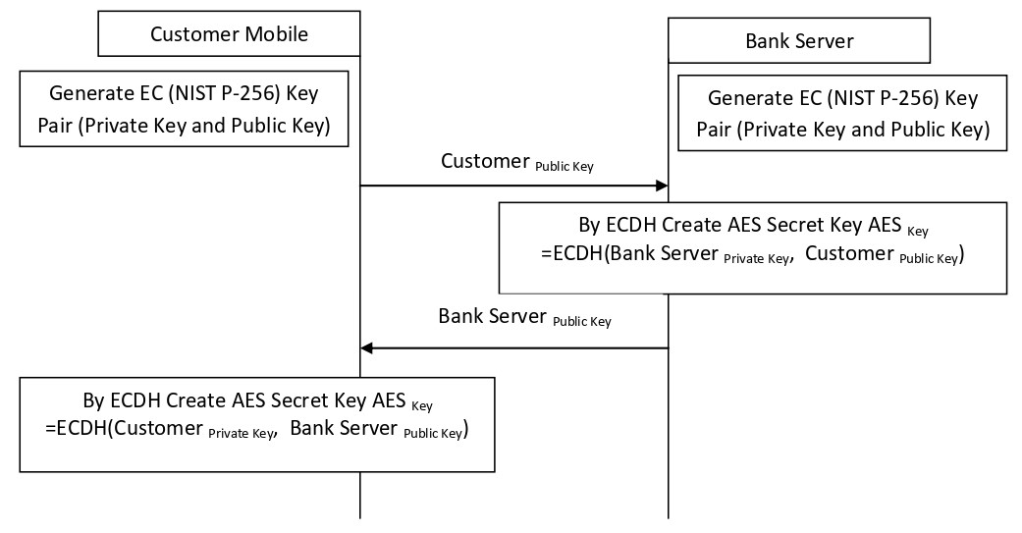

Figure 1. ECDH Key Exchange between Customer mobile and Bank Server.

ECDH Key exchange between Power Server and Bank Server to Generate AES Key.

Figure 2. shows the process of ECDH key exchange between the Power Server and the Bank Server. Both Power Server and Bank Server creates EC Key pair (Private key and Public Key). Bank Server and Power Server share Public keys and then by using Elliptic Curve Diffie-Hellman (ECDH) they create shared secret AES key.

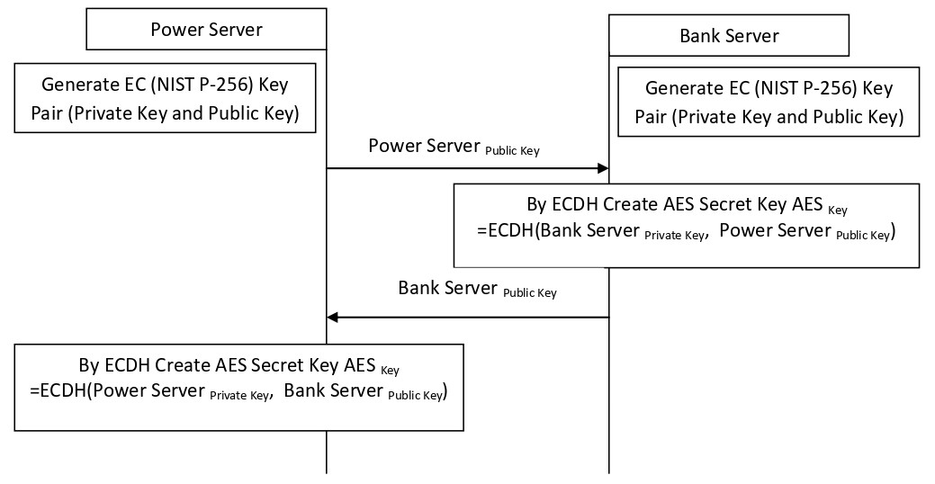

Figure 2. ECDH Key Exchange between Power Server and Bank Server.

Customer Mobile, Power Server and Bank Server AES Encryption & Decryption.

Customer app encrypts payment data with shared AES and sends this encrypted payment data and customer ID to Power Server. Power Server encrypt payment data, customer ID and customer encrypted data with its own shared AES key and sends encrypted data to Bank server. Bank Server decrypts the data by using AES keys. Every encryption or decryption involve initialization vector (IV) and this IV will be transferred between Customer and Bank Server and Power Server and Bank Server. Figure 3 shows encryption and decryption process.

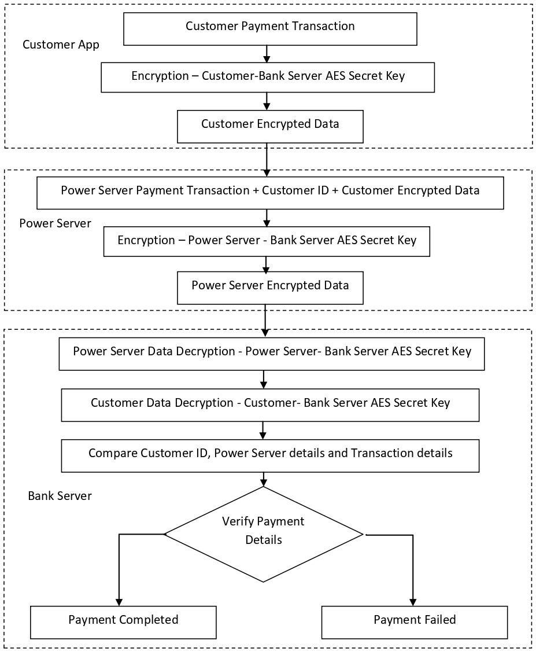

Figure 3. Encryption and Decryption of Process of Customer Payment Data at Customer Mobile, Power Server and Bank Server.

|  |  |
| --- | --- |
|  | |
| Screenshot_20200803-033822.png | Screenshot_20200803-033827.png |
| Figure 4 shows ECDH key exchange process between customer application (MPA) and bank server. EC private key and public key are generated at the customer’s application (MPA) and received at the server public key. By using Customer private key and Bank server’s public key customer application (MPA) generates shared AES key. Similarly Bank server also generates shared AES key by using customer public key and its (Bank server’s) own private key. Figure 5 shows the screen which contain customer information like customer name, customer ID, smart meter ID, connection type and customer address in the MPA. This screen contain button to begin payment. | |
| Screenshot_20200803-033822.png  Figure 5. Customer information | |
|  | |
| Screenshot_20200803-033822.png | |  |
| Figure 6. MPA showing total bill amount and Power Server details | |  |
|  | |  |
|  | |  |
| Figure 6 shows the screen containing Power Server ID, Power Server name and total bill amount and Payment Information (PI). PI is encrypted with the symmetric key shared between the Bank and MPA of the customer. All the attributes including encrypted PI is encrypted with the symmetric key shared between the Electricity Server (ES) and MPA of the customer. Figure 7 shows the screenshot containing customer’s payment transaction’s outcome. After successful payment transfer at the Bank, ES sends a successful message to the customer. | |  |
| Screenshot_20200803-033822.png Screenshot_20200803-033822.png | |  |
| Figure 7. Customer’s MPA showing plain and encrypted transaction and payment status from the Electricity Server (ES) | |  |

|  |  |
| --- | --- |
|  | |
|  |  |
|  | |
|  |  |
|  | |
|  | |
|  | |
|  |  |
|  | |
|  | |
|  | |
|  | |
|  | |
|  | |
|  | |
|  | |
|  | |
|  |  |
|  | |

**Power Server Customer Payment App.**

Power Server Customer Payment App involve a lot of classes. And only the code of ECDHCustomerServer class provided in this report.

**Code of ECDHCustomerServer Class**

**package** com.webmah.powerservercustomerpaymentapp  
  
**import** android.app.Activity  
**import** android.app.KeyguardManager  
**import** android.content.Context  
**import** android.content.Intent  
**import** android.content.SharedPreferences  
**import** android.net.ConnectivityManager  
**import** android.os.Bundle  
**import** android.util.Base64  
**import** android.util.Log  
**import** android.view.View  
**import** android.widget.Toast  
**import** androidx.appcompat.app.AppCompatActivity  
**import** androidx.lifecycle.*lifecycleScope***import** kotlinx.android.synthetic.main.activity\_ecdhcustomerserver.\*  
**import** kotlinx.coroutines.Dispatchers  
**import** kotlinx.coroutines.launch  
**import** kotlinx.coroutines.withContext  
**import** org.json.JSONException  
**import** org.json.JSONObject  
**import** java.io.\*  
**import** java.net.HttpURLConnection  
**import** java.net.URL  
**import** java.security.\*  
**import** java.security.spec.ECGenParameterSpec  
**import** java.security.spec.PKCS8EncodedKeySpec  
**import** java.security.spec.X509EncodedKeySpec  
**import** javax.crypto.Cipher  
**import** javax.crypto.KeyAgreement  
**import** javax.crypto.SecretKey  
**import** javax.crypto.spec.GCMParameterSpec  
**import** javax.crypto.spec.SecretKeySpec  
**import** javax.net.ssl.HttpsURLConnection  
  
  
**class** ECDHCustomerServer : AppCompatActivity() {  
  
 **private lateinit var keyguardManager**: KeyguardManager  
 **private lateinit var keyPair**: KeyPair  
 **private lateinit var keyAES**: SecretKey  
 **private lateinit var signatureResult**: String  
 **private lateinit var enMessage**: String  
 **private val TAG** = **"PSCP"  
 private val iv** = **"123456789abcdefh"**.*toByteArray*()  
 **private lateinit var clientPrivateKey**: PrivateKey  
 **private lateinit var clientPublicKey**: PublicKey  
 **private lateinit var serverPublicKey**: PublicKey  
 **private lateinit var clientAES**: SecretKey  
 **private lateinit var serverResponse**: String  
  
  
 **override fun** onCreate(savedInstanceState: Bundle?) {  
 **super**.onCreate(savedInstanceState)  
 setContentView(R.layout.*activity\_ecdhcustomerserver*)  
  
 **keyguardManager** = getSystemService(Context.*KEYGUARD\_SERVICE*) **as** KeyguardManager  
  
 *//Check if lock screen has been set up. Just displaying a Toast here but it shouldn't allow the user to go forward.* **if** (!**keyguardManager**.*isDeviceSecure*) {  
 Toast.makeText(**this**, **"Secure lock screen hasn't set up."**, Toast.*LENGTH\_LONG*).show()  
 }  
  
 **val** TRANSACTION = *intent*.getStringExtra(**"TRANSACTION"**)  
  
 *//showAuthenticationScreen()  
 //Check if the EC public private keys already exists to avoid creating them again* checkNetworkConnection()  
  
 **val** sharedPreference: SharedPreferences = getSharedPreferences(*SHAREDLOCATION*, Context.*MODE\_PRIVATE*)  
 **var** editor = sharedPreference.edit()  
 editor.clear()  
 editor.commit()  
  
 **if** (!checkECKeysExists()) {  
 generateECKeys()  
 }  
  
 **if** (!checkServerPubKeyExists()) {  
 getServerECPublicKey()  
 }  
  
 accessApp.setOnClickListener **{  
 val** intent = Intent(**this**, CustomerInfo::**class**.*java*)  
 startActivity(intent)  
 **}** }  
  
 **private fun** checkECKeysExists(): Boolean {  
 **val** sharedPreference = getSharedPreferences(*SHAREDLOCATION*, Context.*MODE\_PRIVATE*)  
 *// && sharedPreference.contains("serverPublicKey")* **if**(sharedPreference.contains(**"clientPrivateKey"**) && sharedPreference.contains(**"clientPublicKey"**)){  
 *// decode the base64 encoded string* **val** check = sharedPreference.getString(**"clientPublicKey"**, **"no"**)  
 **if**(check == **"no"**)  
 {  
 **return false** }  
  
 *// decode the base64 encoded string* **val** pukey: ByteArray = Base64.decode(sharedPreference.getString(**"clientPublicKey"**, **"no"**), Base64.*DEFAULT*)  
 **val** keySpec = X509EncodedKeySpec(pukey)  
 **val** keyFactory = KeyFactory.getInstance(**"EC"**)  
 **clientPublicKey** = keyFactory.generatePublic(keySpec)  
  
 **val** prkey: ByteArray = Base64.decode(sharedPreference.getString(**"clientPrivateKey"**, **"no"**), Base64.*DEFAULT*)  
 **val** keySpec1 = PKCS8EncodedKeySpec(prkey)  
 **val** keyFactory1 = KeyFactory.getInstance(**"EC"**)  
 **clientPrivateKey** = keyFactory1.generatePrivate(keySpec1)  
  
 **return true** }  
 **return false** }  
  
 **private fun** generateECKeys() {  
  
 **val** keyGen = KeyPairGenerator.getInstance(**"EC"**)  
 keyGen.initialize(ECGenParameterSpec(**"secp256r1"**), SecureRandom())  
 **val** pair = keyGen.generateKeyPair()  
 **clientPrivateKey** = pair.*private* **clientPublicKey** = pair.*public* **val** prkey = Base64.encodeToString(**clientPrivateKey**.*encoded*, Base64.*DEFAULT*)  
 **val** pkey = Base64.encodeToString(**clientPublicKey**.*encoded*, Base64.*DEFAULT*)  
 System.*out*.println(pkey)  
 **val** sharedPreference = getSharedPreferences(*SHAREDLOCATION*, Context.*MODE\_PRIVATE*)  
 **var** editor = sharedPreference.edit()  
  
 client\_pri.*text* = **"Customer EC Private Key: $**prkey**"** client\_pub.*text* = **"Customer EC Public Key: $**pkey**"** editor.putString(**"clientPrivateKey"**,prkey)  
 editor.putString(**"clientPublicKey"**,pkey)  
 editor.commit()  
 }  
  
 **private fun** checkServerPubKeyExists(): Boolean {  
 **val** sharedPreference = getSharedPreferences(*SHAREDLOCATION*, Context.*MODE\_PRIVATE*)  
 *// && sharedPreference.contains("serverPublicKey")* **if**(sharedPreference.contains(**"serverPublicKey"**)){  
 *// decode the base64 encoded string* **val** check = sharedPreference.getString(**"serverPublicKey"**, **"no"**)  
 **if**(check == **"no"**)  
 {  
 **return false** }  
  
 *// decode the base64 encoded string* **val** pukey: ByteArray = Base64.decode(sharedPreference.getString(**"serverPublicKey"**, **"no"**), Base64.*DEFAULT*)  
 **val** keySpec = X509EncodedKeySpec(pukey)  
 **val** keyFactory = KeyFactory.getInstance(**"EC"**)  
 **serverPublicKey** = keyFactory.generatePublic(keySpec)  
  
 **return true** }  
 **return false** }  
  
 @Throws(JSONException::**class**)  
 **private fun** getServerECPublicKey() {  
 *// clear text result* **serverResponse** = **"no"  
  
 if** (checkNetworkConnection()) {  
 **val** ckey = Base64.encodeToString(**clientPublicKey**.*encoded*, Base64.*DEFAULT*)  
 **val** jsonObject = JSONObject()  
 jsonObject.accumulate(**"clientPublicKeyEC"**, ckey)  
 *lifecycleScope*.*launch* **{  
 val** result = httpPost(**"https://webmah.com/powerservercustomerpaymentapp/ServerAuthAtClient.php"**, jsonObject)  
  
 **val** responseparts = **serverResponse**.*split*(**"-------"**)  
 **val** serpukey: ByteArray = Base64.decode(responseparts[0], Base64.*DEFAULT*)  
 **val** keySpec = X509EncodedKeySpec(serpukey)  
 **val** keyFactory = KeyFactory.getInstance(**"EC"**)  
 **serverPublicKey** = keyFactory.generatePublic(keySpec)  
  
 **val** spkey = Base64.encodeToString(**serverPublicKey**.*encoded*, Base64.*DEFAULT*)  
 System.*out*.println(**"ServerPublic Key:"**+spkey)  
 **val** sharedPreference = getSharedPreferences(*SHAREDLOCATION*, Context.*MODE\_PRIVATE*)  
 **var** editor = sharedPreference.edit()  
  
 server\_pub.*text* = **"Bank Server EC Public Key: $**spkey**"** editor.putString(**"serverPublicKey"**,spkey)  
 editor.commit()  
  
 **if** (!checkSharedAESKeyExists()) {  
 getSharedAESKey()  
 }  
  
 *//decrypt signature* **val** cipher = Cipher.getInstance(*TRANSFORMATION*)  
 *//We decode the signature value  
 //serverensign\_txt.text = "Server Encrypted Signature: $responseparts[1]"* **val** ensign: ByteArray = Base64.decode(responseparts[1], Base64.*DEFAULT*)  
 **val** serverIV: ByteArray = Base64.decode(responseparts[2], Base64.*DEFAULT*)  
  
 cipher.init(Cipher.*DECRYPT\_MODE*, **clientAES**, GCMParameterSpec(128, serverIV))  
 **val** decodedData: ByteArray = cipher.doFinal(ensign)  
  
 **var** ssignstr = Base64.encodeToString(decodedData, Base64.*DEFAULT*)  
 *//System.out.println("Server Signature:"+ssignstr)* verifyServerSign(decodedData)  
 **}** }  
 **else** Toast.makeText(**this**, **"Not Connected!"**, Toast.*LENGTH\_SHORT*).show()  
  
 }  
  
 **private fun** checkSharedAESKeyExists(): Boolean {  
 **val** sharedPreference = getSharedPreferences(*SHAREDLOCATION*, Context.*MODE\_PRIVATE*)  
 *// && sharedPreference.contains("serverPublicKey")* **if**(sharedPreference.contains(**"clientAES"**)){  
 *// decode the base64 encoded string* **var** seck = sharedPreference.getString(**"clientAES"**, **"no"**)  
 **if**(seck == **"no"**)  
 {  
 **return false** }  
  
 **val** secKey: ByteArray = Base64.decode(seck, Base64.*DEFAULT*)  
 **clientAES** = SecretKeySpec(secKey, 0, secKey.**size**, **"AES"**)  
  
 **return true** }  
 **return false** }  
  
 **private fun** getSharedAESKey() {  
 **val** secretKeyAES: SecretKey? = generateSharedSecret(**clientPrivateKey**, **serverPublicKey**)  
  
 **if** (secretKeyAES != **null**) {  
 **clientAES** = secretKeyAES  
 }  
  
 **val** aeskey = Base64.encodeToString(secretKeyAES?.*encoded*, Base64.*DEFAULT*)  
 System.*out*.println(**"Client AESKey:"**+aeskey)  
 **val** sharedPreference = getSharedPreferences(*SHAREDLOCATION*,Context.*MODE\_PRIVATE*)  
 **var** editor = sharedPreference.edit()  
  
 client\_aes.*text* = **"ECDH Generated AES Key:$**aeskey**"** editor.putString(**"clientAES"**,aeskey)  
 editor.commit()  
 }  
  
 **private fun** generateSharedSecret(privateKey: PrivateKey?, publicKey: PublicKey?): SecretKey? {  
 **return try** {  
 **val** keyAgreement: KeyAgreement = KeyAgreement.getInstance(**"ECDH"**)  
 keyAgreement.init(privateKey)  
 keyAgreement.doPhase(publicKey, **true**)  
 **val** key: ByteArray = keyAgreement.generateSecret()  
 *//String ke = Base64.getEncoder().encodeToString(key);  
 //System.out.println(ke);* SecretKeySpec(key, 0, key.**size**, **"AES"**)  
 } **catch** (e: java.lang.Exception) {  
 e.printStackTrace()  
 **null** }  
 }  
  
 **private fun** verifyServerSign(serversign: ByteArray?) {  
 **try** {  
  
 *//val signature: ByteArray = Base64.decode(serversign, Base64.DEFAULT)* **val** sharedPreference = getSharedPreferences(*SHAREDLOCATION*, Context.*MODE\_PRIVATE*)  
 *// && sharedPreference.contains("serverPublicKey")* **if**(sharedPreference.contains(**"clientPublicKey"**)) {  
 *// decode the base64 encoded string* **var** seck = sharedPreference.getString(**"clientPublicKey"**, **"no"**)  
 System.*out*.println(**"Client PublicKey:"**+seck);  
  
 *//We check if the signature is valid. We use ECDSA algorithm along SHA-256 digest algorithm* **val** isValid: Boolean = Signature.getInstance(**"SHA256withECDSA"**).*run* **{** initVerify(**serverPublicKey**)  
 **if** (seck != **null**) {  
 update(Base64.decode(seck, Base64.*DEFAULT*))  
 }  
 verify(serversign)  
 **}  
 if** (isValid) {  
 System.*out*.println(**"valid: Server Authenticated "**);  
 *//server\_verified.text = "Server Authentication Successful at Client"* verifyClintAtServer()  
  
 } **else** {  
 System.*out*.println(**"notvalid: Server Authentication Failed"**);  
 *//server\_verified.text = "Server Authentication Failed at Client"* }  
  
 }  
  
 } **catch** (e : Exception){  
 **throw** RuntimeException(e)  
 }  
 }  
  
 @Throws(JSONException::**class**)  
 **private fun** verifyClintAtServer() {  
 *// clear text result* **serverResponse** = **"no"  
  
 val** cipher = Cipher.getInstance(*TRANSFORMATION*)  
  
 **val** parameterSpec = GCMParameterSpec(128, **iv**)  
 cipher.init(Cipher.*ENCRYPT\_MODE*, **clientAES**, parameterSpec)  
  
 **val** bytes = cipher.doFinal(createClientSign())  
 **val** clientENSign = Base64.encodeToString(bytes, Base64.*DEFAULT*)  
  
 *//client\_sign.text = "Client Signature: $clientENSign"* **val** ivs = Base64.encodeToString(**iv**, Base64.*DEFAULT*)  
  
  
 **if** (checkNetworkConnection()) {  
 **val** jsonObject = JSONObject()  
 jsonObject.accumulate(**"iv"**, ivs)  
 jsonObject.accumulate(**"clientENSign"**, clientENSign)  
 *lifecycleScope*.*launch* **{  
 val** result = httpPost(**"https://webmah.com/powerservercustomerpaymentapp/ClientAuthAtServer.php"**, jsonObject)  
 *//client\_verified.text = serverResponse* **if**(**serverResponse**.*contains*(**"Successfully"**, ignoreCase = **true**))  
 {  
 accessApp.*visibility* = View.*VISIBLE*; *//To set visible* }  
 **}** }  
 **else** Toast.makeText(**this**, **"Not Connected!"**, Toast.*LENGTH\_SHORT*).show()  
  
 }  
  
 **private fun** createClientSign(): ByteArray? {  
 **try** {  
 *//val signature: ByteArray = Base64.decode(serversign, Base64.DEFAULT)* **val** sharedPreference = getSharedPreferences(*SHAREDLOCATION*, Context.*MODE\_PRIVATE*)  
 *// && sharedPreference.contains("serverPublicKey")* **if**(sharedPreference.contains(**"serverPublicKey"**)) {  
 *// decode the base64 encoded string* **var** seck = sharedPreference.getString(**"serverPublicKey"**, **"no"**)  
  
 *//We sign the data with the private key. We use ECDAS algorithm along SHA-256 digest algorithm* **val** signature: ByteArray? = Signature.getInstance(**"SHA256withECDSA"**).*run* **{** initSign(**clientPrivateKey**)  
 update(Base64.decode(seck, Base64.*DEFAULT*))  
 sign()  
 **}  
 return** signature  
 }  
 } **catch** (e : Exception){  
 **throw** RuntimeException(e)  
 }  
 **return null** }  
  
  
 **private fun** showAuthenticationScreen() {  
 *//This will open a screen to enter the user credentials (fingerprint, pin, pattern). We can display a custom title and description* **val** intent: Intent? = **keyguardManager**.createConfirmDeviceCredentialIntent(**"User Authentication"**,  
 **"To be able to use this Smart Meter Secure App we need to confirm your identity. Please enter your pin/pattern or scan your fingerprint"**)  
 **if** (intent != **null**) {  
 startActivityForResult(intent, *REQUEST\_CODE\_FOR\_CREDENTIALS*)  
 }  
 }  
  
 **override fun** onActivityResult(requestCode: Int, resultCode: Int, data: Intent?) {  
 **if** (requestCode == *REQUEST\_CODE\_FOR\_CREDENTIALS*) {  
 **if** (resultCode == Activity.*RESULT\_OK*) {  
 } **else** {  
 Toast.makeText(**this**, **"Authentication failed."**, Toast.*LENGTH\_SHORT*).show()  
 }  
 }  
 }  
  
  
  
 @Throws(IOException::**class**, JSONException::**class**)  
 **private suspend fun** httpPost(myUrl: String, jsonObject: JSONObject): String {  
  
 **val** result = withContext(Dispatchers.**IO**) **{  
 val** url = URL(myUrl)  
 *// 1. create HttpURLConnection* **val** conn = url.openConnection() **as** HttpsURLConnection  
 conn.*requestMethod* = **"POST"** conn.setRequestProperty(**"Content-Type"**, **"application/json; charset=utf-8"**)  
  
 *// 2. build JSON object  
 //val jsonObject = buidJsonObject()  
  
 // 3. add JSON content to POST request body* setPostRequestContent(conn, jsonObject)  
  
 *// 4. make POST request to the given URL* conn.connect()  
  
 *// 5. return response message* conn.*responseMessage* + **""  
  
 if** (conn.*responseCode* == HttpsURLConnection.*HTTP\_OK*) {  
 **val** stream = BufferedInputStream(conn.*inputStream*)  
 **serverResponse** = readStream(inputStream = stream)  
 } **else** {  
 **serverResponse** = **"Problem in Getting Server Response"** }  
  
 **}  
 return** result.toString()  
 }  
  
 **private fun** checkNetworkConnection(): Boolean {  
 **val** connMgr = getSystemService(Context.*CONNECTIVITY\_SERVICE*) **as** ConnectivityManager  
  
 **val** networkInfo = connMgr.*activeNetworkInfo* **val** isConnected: Boolean = **if**(networkInfo != **null**) networkInfo.isConnected() **else false  
 if** (networkInfo != **null** && isConnected) {  
 *// show "Connected" & type of network "WIFI or MOBILE"* howIsConnected.*text* = **"Connected "** + networkInfo.*typeName* } **else** {  
 *// show "Not Connected"* howIsConnected.*text* = **"Not Connected"** }  
 **return** isConnected  
 }  
  
 @Throws(JSONException::**class**)  
 **private fun** buidJsonObject(): JSONObject {  
  
 **val** pkey = Base64.encodeToString(**clientPublicKey**.*encoded*, Base64.*DEFAULT*)  
 **val** skey = Base64.encodeToString(**clientAES**.*encoded*, Base64.*DEFAULT*)  
 **val** ivs = Base64.encodeToString(**iv**, Base64.*DEFAULT*)  
  
  
 **val** jsonObject = JSONObject()  
 jsonObject.accumulate(**"aeskey"**, skey)  
 jsonObject.accumulate(**"iv"**, ivs)  
 jsonObject.accumulate(**"encryptedTransaction"**, **enMessage**)  
 jsonObject.accumulate(**"publickey"**, pkey)  
 jsonObject.accumulate(**"signature"**, **signatureResult**)  
  
 **return** jsonObject  
 }  
  
 @Throws(IOException::**class**)  
 **private fun** setPostRequestContent(conn: HttpURLConnection, jsonObject: JSONObject) {  
  
 **val** os = conn.*outputStream* **val** writer = BufferedWriter(OutputStreamWriter(os, **"UTF-8"**))  
 writer.write(jsonObject.toString())  
 Log.i(**TAG**, jsonObject.toString())  
 writer.flush()  
 writer.close()  
 os.close()  
 }  
  
 **private fun** readStream(inputStream: BufferedInputStream): String {  
 **val** bufferedReader = BufferedReader(InputStreamReader(inputStream))  
 **val** stringBuilder = StringBuilder()  
 bufferedReader.*forEachLine* **{** stringBuilder.append(**it**) **}  
 return** stringBuilder.toString()  
 }  
  
}  
  
**private const val** *REQUEST\_CODE\_FOR\_CREDENTIALS* = 1  
**private const val** *TRANSFORMATION* = **"AES/GCM/NoPadding"  
private const val** *SHAREDLOCATION* = **"POWERSERVERCUSTOMERPAYMENTAPP"**